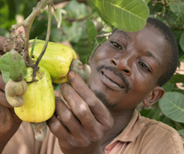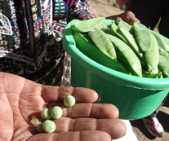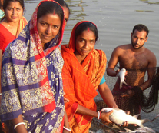

For many of the world’s poorest countries, smallholder agriculture is the core of the economy and the chief means of food security for the rural population. Yet many smallholders fail to secure their own livelihoods due to a combination of environmental, climatic, social, and economic constraints. By identifying potential opportunities, and devising multiple entry points for different target groups to access secure livelihood opportunities, CARE’s approach ensures that the poor and ultra-poor are afforded the best-suited means of overcoming barriers to food security.

The model highlights the importance of combining push and pull strategies with sensitivity to the varying economic capabilities of HHs. Building on a base of safety net support, tailored combinations of these strategies will result in diversified livelihoods, a stronger asset base, improved nutritional status, and strengthened community resilience to exogenous shocks.

households into the formal sector for sustainable food access and asset accumulation, and c) enhance food utilization and “resilience” to shocks and change in individuals, households, communities and the environment. The three strategies are interdependent and together offer a sure pathway for equitable economic resilience.

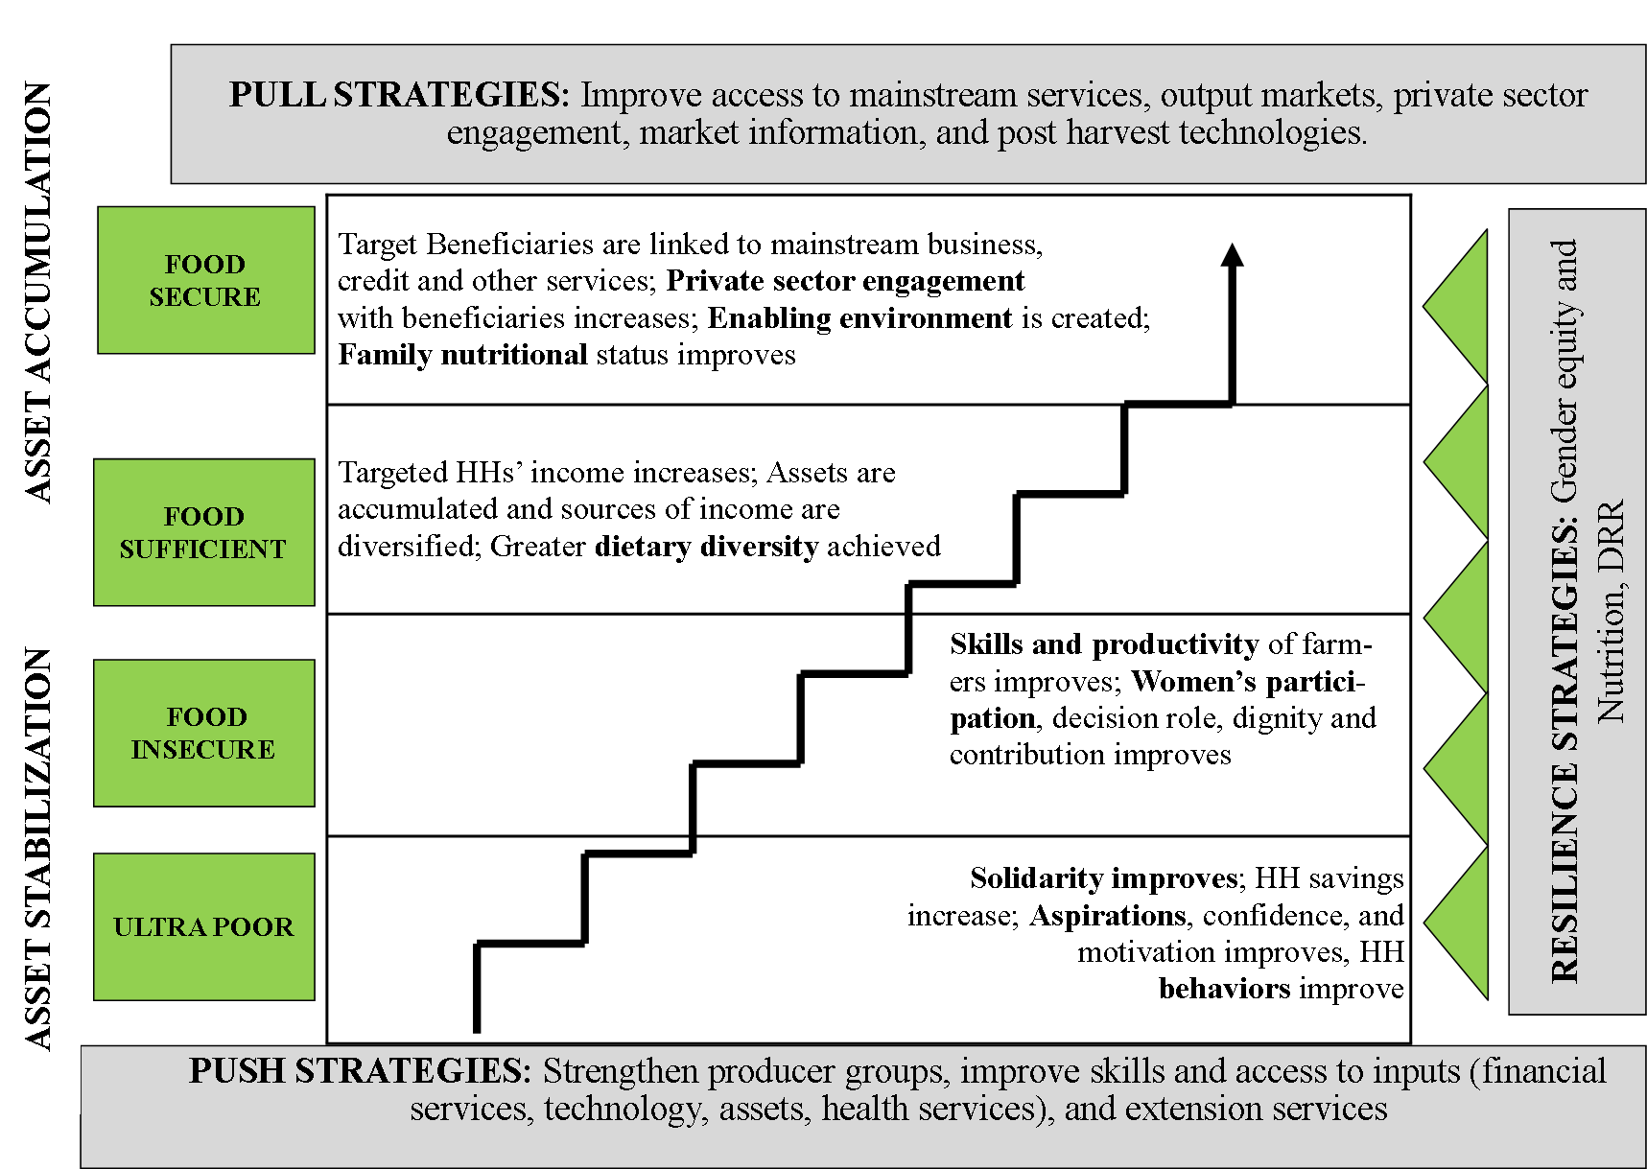

CARE’s approach to food security programming is designed around barriers to productive participation in agriculture and empowerment faced by farmers, especially women. Our food security program design is based on the understanding that development interventions that broadly target a general category of smallholders are unlikely to benefit the more vulnerable among these groups. CARE addresses the most challenging causes of food insecurity, including low agricultural productivity, marginalization of women smallholder farmers in agriculture, and access to markets and financial services. Our approach tailors CARE’s global experience in sustainable agriculture, women’s empowerment, market engagement, microfinance, nutrition and climate change with the pathways toward secure and resilient livelihoods for different segments of poor farmers.

Graduation to Resilience
CARE’s program model is designed to promote graduation of beneficiaries from conditions of vulnerability and chronic food insecurity to sustainable food security, employing strategies that a) act to give the most vulnerable households an initial ‘push’ toward asset stabilization and support food availability, b) ‘pull’ increasingly viable

Integrated Food Security Programming
CARE’s food security programming begins with an analysis of target beneficiaries and households (HHs) to understand the barriers to improved food security. Our analysis takes into account a HHs resilience to internal and external shocks that are often the immediate barriers to attaining food security. CARE’s program design is consequently built on a model that is focused on sustainability by designing interventions that address the multi-dimensional (individual, relational, and structural) barriers to HH food security. A priority is placed on understanding the impact that gender has on food security, ensuring that program interventions do not over-burden women, but rather, advance gender equality.
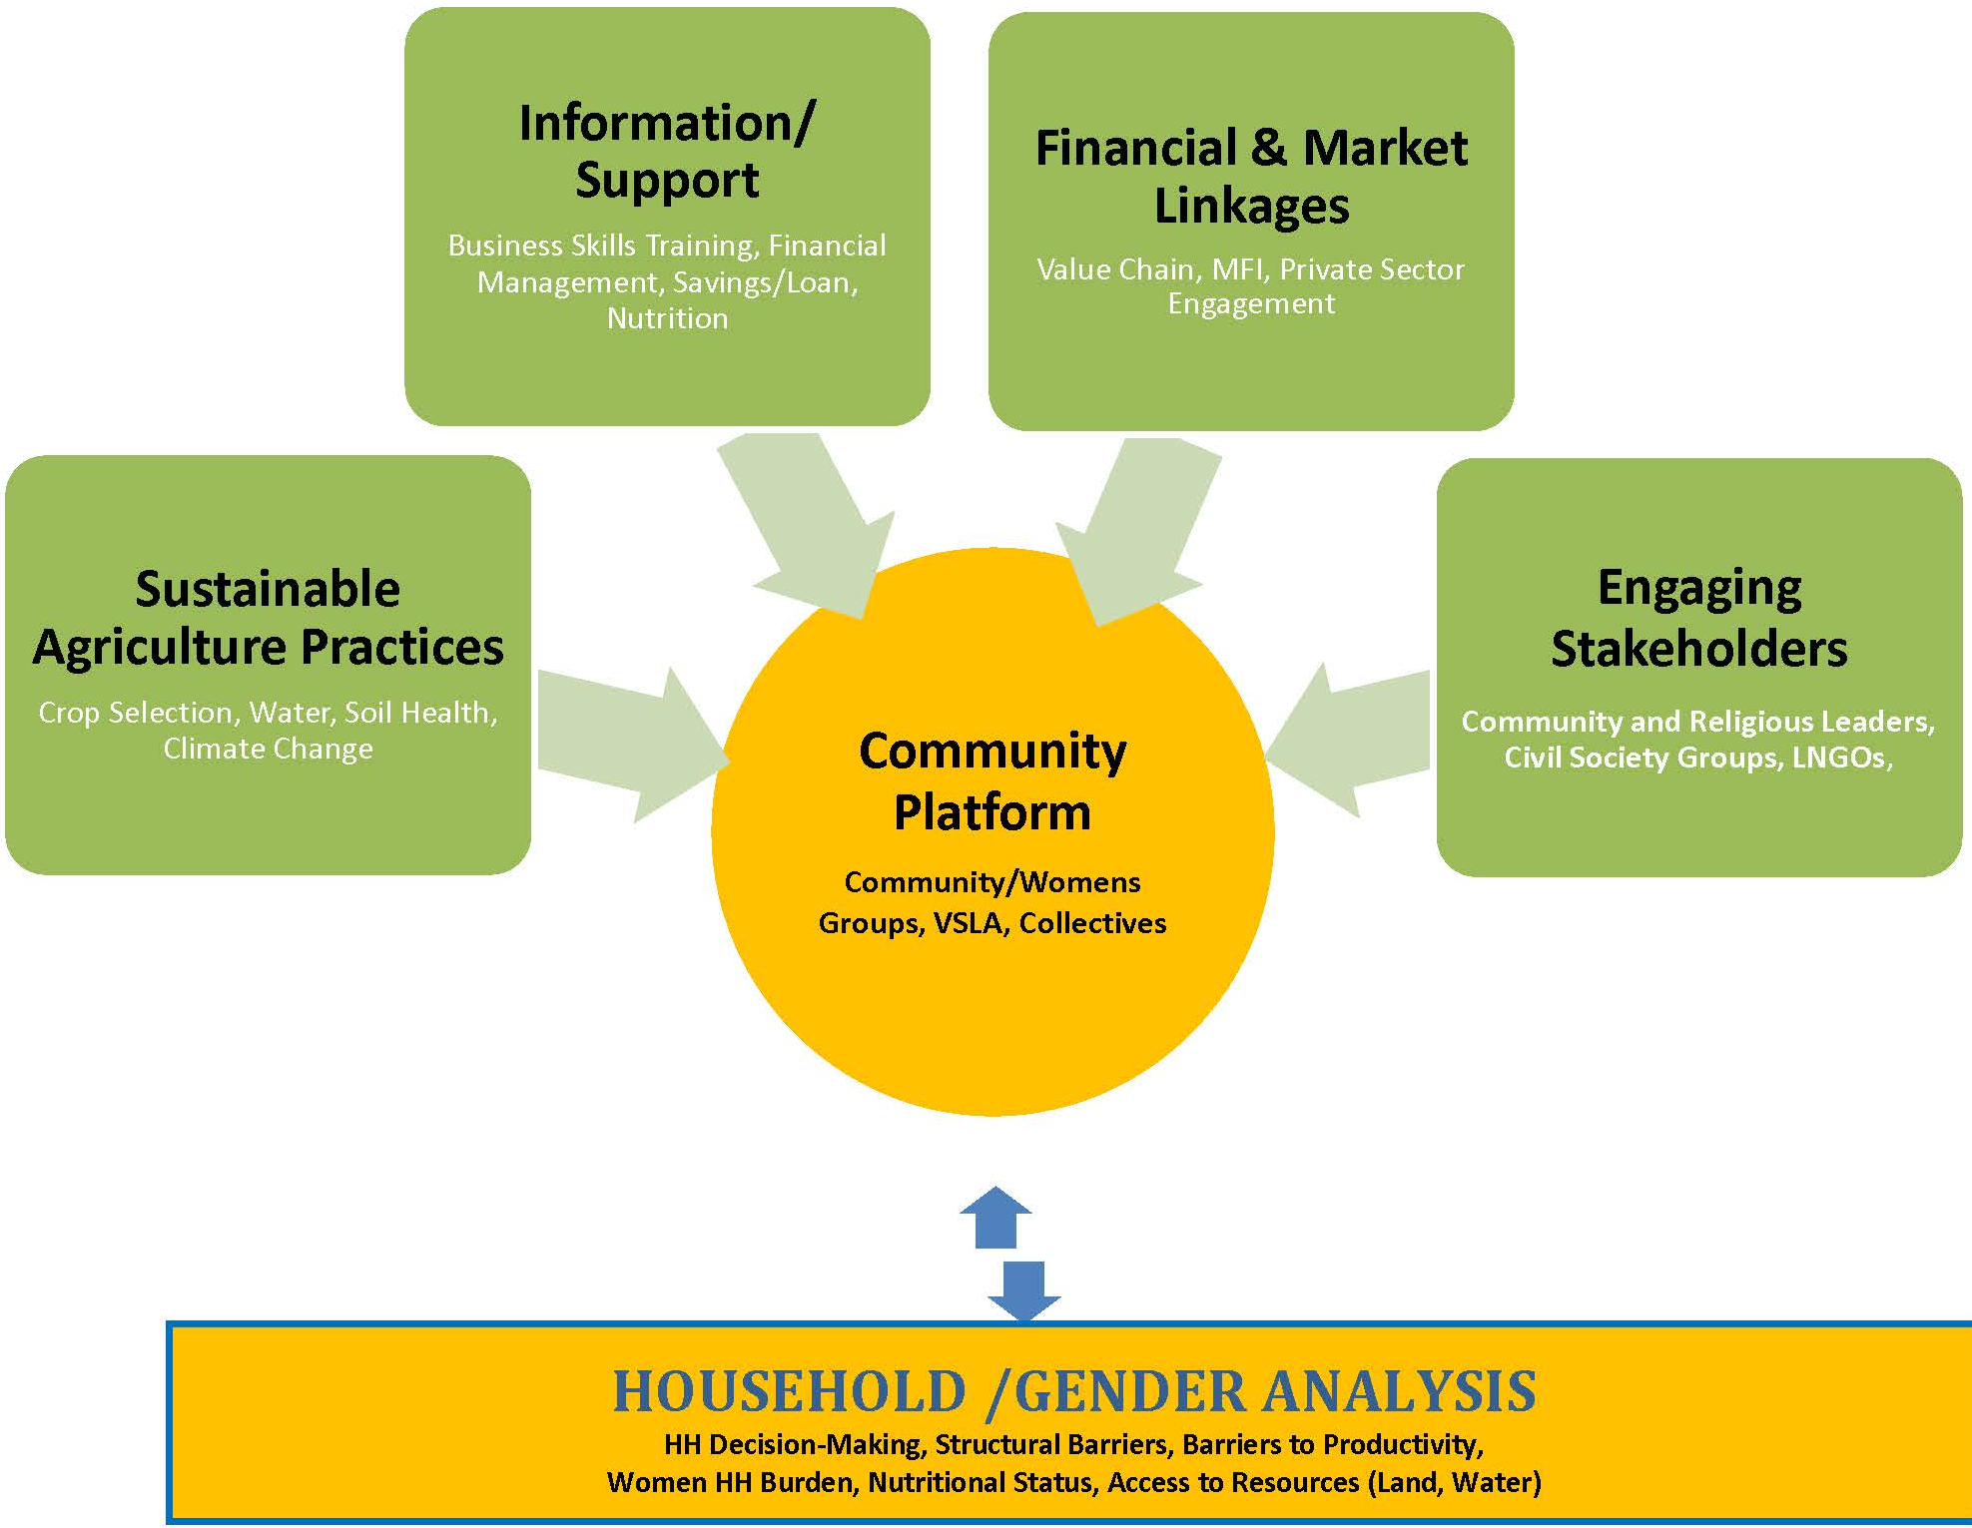
CARE’s approach to food security often includes selecting a broad range of collectives, such as self-help groups, VSLAs, water user associations, forest user groups, and various producer collectives to facilitate the engagement of beneficiaries. These fora serve as a common platform to disseminate information on health and nutrition, training on business skills development, and establishing group savings and loan mechanisms. The intent is to promote behavior change at the HH and community levels so that beneficiaries are able to access and control various resources and activities within households and with formal institutions. The result is a sustainable processes that creates greater accountability to poor farmers broadly among service providers and local and national authorities; and encourages women to assume leadership roles in promoting the adoption of sustainable agriculture practices to reach others outside of their own groups.
CARE’s food security programs target the specific needs of individuals and HHs through tailored interventions that promote resilience and graduate households into long term food security. Program interventions promote the following:
- Sustainable and intensified agriculture practices to overcome environmental and climate challenges and insufficiency of skills while increasing agricultural outputs. Agricultural productivity is improved in part by facilitating increased access to land, water management, selection of the most strategic crops for women farmers and linkages to technical information and support services.
- Programs also encourage women to enter into higher-value crop production and non-farm income-generating activities, such as small-scale processing and trading, which further supports household diversification and livelihood strategies.
- By indentifying the most critical structural barriers that limit the productivity of poor farmers, CARE’s programming facilitates access to markets and services, often by making use of a gendered value chain analysis and approaches. Interventions can suit a variety of purposes, depending on the country.
- Through all of CARE’s programs, a priority is placed on understanding the implications and impacts gender has on attaining food security and ensuring that all activities advance gender equality and avoid (even inadvertently) over-burdening women. Programs systematically analyze gender dynamics within the household, ensuring the interventions promote gender equality at all levels.
- Our approach promotes appropriate changes in behavior at the community level that includes building a support system for individuals and households to achieve optimal household health and nutrition, focused on vulnerable populations including women, children and people living with HIV/AIDS in resource poor environments.

The Graduation Model in Practice
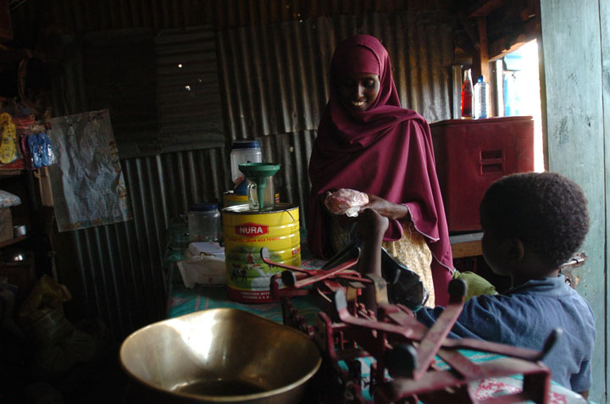
CARE Ethiopia has received funding to implement the Graduation with Resilience to Achieve Sustainable Development (GRAD) program. The goal of GRAD is to contribute significantly to sustained food security by graduating 50,000 chronically food insecure HHs from the Government Productive Safety Nets Program (PSNP) to long term food security and productive livelihoods. To achieve this ambitious objective, GRAD targets some of the poorest households in Ethiopia in an economically, climactically and socially dynamic context. The approach combines “push” and “pull” elements into a complete and integrated package of interventions for on- and off-farm opportunity creation, access to financial products, and demand-oriented extension services. By focusing on five value chains—dairy, honey, meat, pulses and vegetables—GRAD will build and nurture partnerships with private sector actors in these specific sectors. In order to address some of the key underlying causes of vulnerability, thereby increasing resiliency at household and community levels, investments include a range of strategies designed to increase gender equality, improve nutrition, enhance climate change adaptation and stimulate graduation aspirations among PSNP households.
GRAD has been designed around principles of gender primacy, social accountability and linkages and leveraging. In practical terms, this means that every program activity will consciously aim to further gender equality, ensure accountability to beneficiaries and to intensify impact through collaboration and influence.
The model highlights the importance of combining push and pull strategies with sensitivity to the varying economic capabilities of HHs. Building on a base of safety net support, tailored combinations of these strategies will result in diversified livelihoods, a stronger asset base, improved nutritional status, and strengthened community resilience to exogenous shocks. As a result, targeted HHs’ income will increase by $365 per year by the end of the project.

