Seeking Greater Flexibility in the Fight against Global Hunger
A Message from Seven Leading Development Agencies working on
Local and Regional Procurement Programs
for submission to the Senate Agricultural Committee, Farm Bill 2012
As implementers of international food assistance programs, we have seen firsthand that the Local and Regional Procurement (LRP) of food can be a useful development tool. While you undertake the reauthorization process for the Farm Bill, we ask you to consider making LRP a permanent component of U.S. food assistance programs.
In an effort to provide emergency food assistance and to end chronic hunger, the humanitarian relief and development community is continually looking for ways to improve the efficiency and effectiveness of its services. In that spirit, the 2008 Farm Bill created the LRP Pilot Program, implemented through the U.S. Department of Agriculture. The program was mandated by Congress to assess whether LRP was an effective food assistance mechanism that maintained core humanitarian principles.
A group of implementing organizations, included in the undersigned, worked in partnership with Dr. Christopher B. Barrett and his team from Cornell University’s School of Applied Economics and Management to evaluate the impacts of their LRP programs. The Cornell study found that:
- On average, procuring food locally or distributing vouchers or cash for the local purchase of food resulted in a time savings of nearly fourteen weeks compared with shipping food from the U.S., a 62 percent gain in timeliness.
- Cost savings were realized for local procurement of unprocessed grains and some pulses—around 50 percent. However, procuring processed foods and vegetable oils did not achieve these same savings. Cost savings also varied by geographic region, with the greatest savings for procurements in Africa and Asia.
- In most cases studied, LRP procurement and distribution activities did not impact local market price levels.
In addition, LRP has shown the potential to promote sustainable impacts through harnessing the outputs of local farmers, collaborating with other private sector actors, and linking with existing development initiatives. For example, Land O’Lakes worked with local processing companies in Bangladesh that procured locally produced, nutritious ingredients. These commodities were used to produce 15 million fortified cereal bars, which provided a daily snack to around 100,000 students and teachers in 441 primary schools. The program not only played a catalytic role in increasing school attendance and enrollment by over 25 percent, but also spurred Bangladeshi processors to commercialize the product. Since then, the processors have produced over one million high energy cereal bars, which are being sold through local retail markets.
As detailed above, the pilot study showed LRP programs could achieve significant cost savings and timeliness gains, although program implementer experience suggests these savings can vary, depending on context. As Cornell highlighted, “LRP runs a real… risk of unreasonable expectations that it can meet multiple, sometimes competing, objectives.”
The context of any food crisis should frame the decision on which balance of food assistance mechanisms are used in the resulting food assistance program. In cases where markets are working but people need short term assistance, food vouchers and cash can meet short term needs. Where local and regional markets are capable of supplying adequate food volume over time without adverse food price impacts, LRP is also highly useful tool. But when the volume of food needs outstrips the capacity of local and regional market systems, traditional food assistance through bulk shipments of in-kind food is critical to provide the essential heavy lifting to support millions in need.
The local and regional procurement of food provides humanitarian and development organizations with greater flexibility to tailor food assistance programming to diverse contexts. LRP should be considered a vital tool along with other essential food aid mechanisms, including emergency and development Title II, Food for Progress and McGovern Dole programs. But LRP should be seen as a complement to, rather than a replacement of, these other mechanisms, and should not change the balance of developmental and emergency resources within the Farm Bill.
We the undersigned support increased flexibility in using LRP to effectively fight global hunger. With this flexibility the U.S. Government and its implementing partners will be able to best meet the needs of those facing emergencies and chronic hunger, while also maintaining accountability to U.S. taxpayers.

Signed,
  CARE  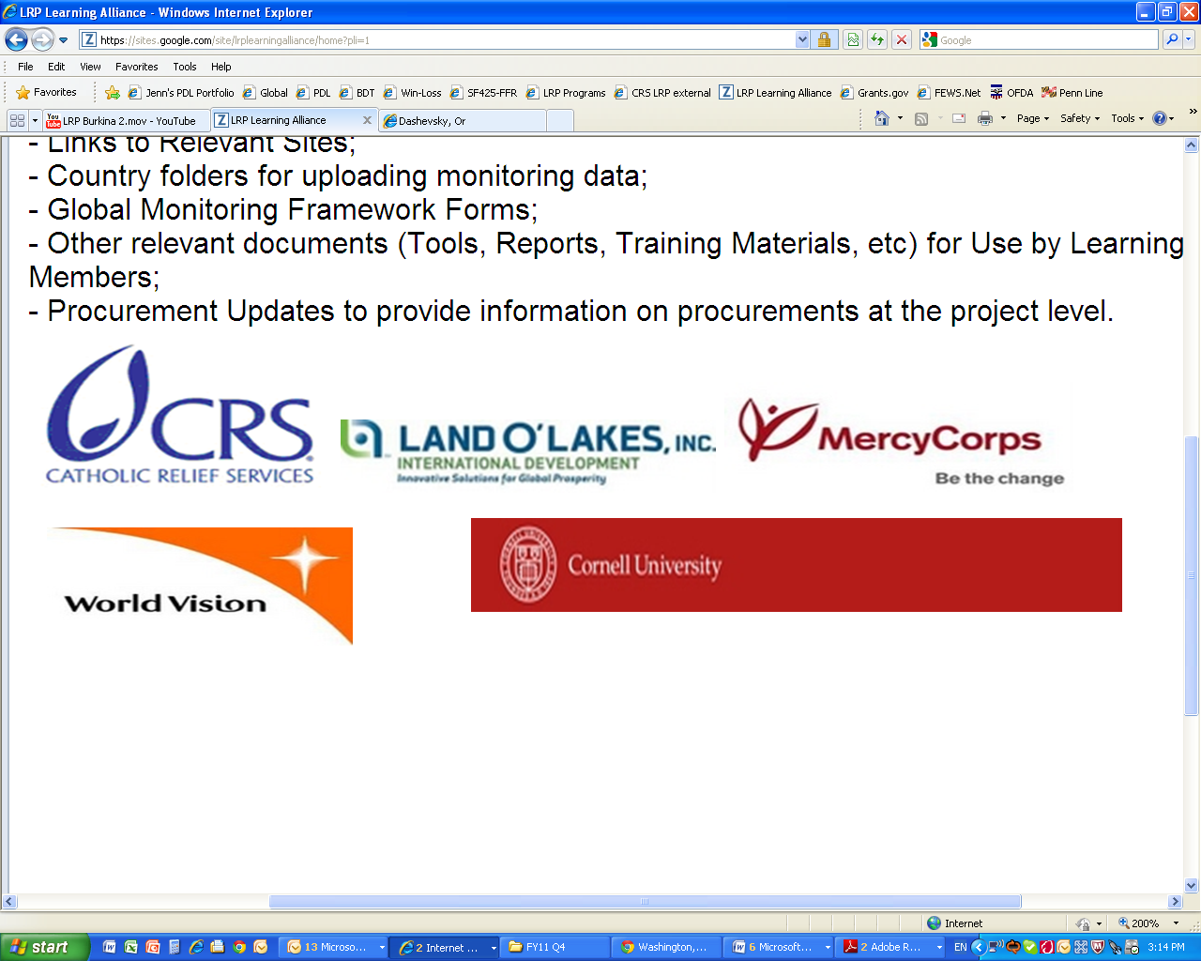  Catholic Relief Services |   Fabretto Children’s Foundation    International Relief &  Development  Land O’Lakes, Inc. | Mercy Corps  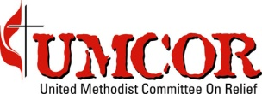  United Methodist Committee on Relief

Erin C. Lentz, Christopher B. Barrett and Miguel I. Gómez, "The Impacts of Local and Regional Procurement of US Food Aid: Learning Alliance Synthesis Report," Final Report: A Multidimensional Analysis of Local and Regional Procurement of US Food Aid, January 2012.

